BSCS FINAL PROJECT
Rapid Rescue



Project Advisor

Asif Farooq

Presented by:
Group ID: F24BS044

Student Reg# Student Name

L1F21BSCS1039 | TALHA JAVED
L1S21BSCS0105 | FAHEEM KHAN
L1F21BSCS1214 | JAWAD AHMAD

Faculty of Information Technology

University of Central Punjab
Software Design Specification
SDP Phase II

Rapid Rescue
Advisor: Asif Farooq

Team F24BS044
Member Name | Primary Responsibility
Faheem Khan | All Work is Done Equally
Talha Javed | All Work is Done Equally
Jawad Ahmad | All Work is Done Equally

Table of Contents
Table of Contents i
Revision History ii
Abstract iii
1. Introduction 1
1.1 Product 1
1.2 Background 1
1.3 Objective(s)/Aim(s)/Target(s) 1
1.4 Scope 1
1.5 Business Goals 2
1.6 Document Conventions 2
1.7 Miscellaneous 2
2. Overall Description 3
2.1 Product Features 3
2.2 Functional Description 3
2.3 User Classes and Characteristics 3
2.4 Design and Implementation Constraints 5
2.5 Assumptions and Dependencies 5
3. Technical Architecture 6
3.1 Application and Data Architecture 7
3.2 Component Interactions and Collaborations 14
3.3 Design Reuse and Design Patterns 16
3.4 Technology Architecture 16
4. Screenshots/Prototype 18
4.1 Workflow 18
4.2 Screens 19
5. Other Design Details 19
6. Revised Project Plan 20
7. References 20
Appendix A: Glossary 20
Appendix B: IV & V Report 21

Revision History
Name | Date | Reason For Changes | Version

Abstract
The traditional method of Road accident reporting relies on citizen calls, often resulting in delays in emergency response. So, to eliminate critical delays in emergency response and improve the efficiency of ambulance services, our project introduces an innovative system utilizing traffic cameras to detect traffic accidents and send alerts to the nearest ambulance services. Upon detection, the system notifies the closest ambulance services of the accident, ensuring a rapid response.

Our project, Rapid Rescue, is based on artificial intelligence merged with video streams to recognize accidents. This is followed by notification to ambulances about the accident, its location, and the way to the accident location. This ensures accuracy, thus improving the emergency services of urban areas and saving people's lives.

Computer vision algorithms analyze video feeds from strategically placed cameras to identify accidents. In addition to the detection and notification system, an application will feature a management dashboard for ambulance services. This dashboard will store accident location data.

Introduction

Product
The current emergency response systems are suffering from serious delays, largely due to the reliance on manual reporting of accidents. In most cases, such delays cause a difference between life and death. For this reason, urban centers are marred by congestion, inefficient communication in most settings, and lack of real-time insight into accidents, frustrating efforts to get ambulances to accident scenes on time. These inefficiencies underscore the urgent need for an accident detection system and accurate, actionable data for services that save precious response time. Our product “Rapid Rescue” responds to the critical problem of delayed emergency response. As a result, it optimizes dispatch operations to minimize response times and save lives.

Background
Emergency response systems form an important part of urban infrastructure. They are supposed to save human lives in accidents, but most current systems are incompetent, primarily due to inefficiencies in the reporting and dispatching of ambulances. These inefficiencies mainly arise due to an overwhelming dependence on manual processes that may delay the detection and response to accidents.
With advancements in technology, artificial intelligence has emerged as a powerful tool for improving emergency services. AI-driven systems can automate accident detection, reducing dependency on human intervention, while real-time analytics enable communication with ambulance services.
Having studied the limitations of traditional systems and considered state-of-the-art technologies, we suggest ‘Rapid Rescue” as an innovation in this regard. This product uses AI and computer vision to detect traffic accidents from video feeds, ensuring immediate alerts and dispatch routes for ambulances.
Rapid Rescue builds on existing research in intelligent traffic systems and real-time analytics to identify gaps, such as computer vision with real-time ambulance dispatch and geolocation services. This project will contribute to more efficient and life-saving responses in an emergency system that is fit for urban environments.

Objective(s)/Aim(s)/Target(s)
- Build an AI system for real-time accident detection.
- Real-time communication for optimized ambulance dispatch
- Provide a dashboard for stats and analysis.

Scope
Rapid Rescue's scalable and AI-driven system transforms emergency response in urban areas by eliminating the lag involved with dispatching ambulances. It uses video analytics to automatically detect road accidents and feeds the location with precision to the accessible ambulances. This system is scalable for deployment across urban centers and supports real-time monitoring, thus ensuring higher efficiency in terms of response and in alignment with smart city initiatives that also improve public safety.
This service-oriented system perfectly meshes with existing frameworks. Emergency operators, along with urban planners, can use the system to increase response rates and gain information regarding trends in accidents.

Business Goals
Minimize Emergency Response Times:
Cut down the ambulance time-to-accident scene using real-time AI-based accident detection.

Accuracy in Accident Detection:
Real-time video analytics and Artificial Intelligence powered it results in better detection accuracy as well as reducing false positives.

Data-Driven Decision-Making Facilitation:
An analytics dashboard offering review of the responses, allowing ambulance services to make improvements.

Easy Integration:
It is worth developing a service-oriented approach that can integrate into the emergency framework offered by frameworks using APIs, thus minimal overhaul at the user end.

Document Conventions
The fonts and size that we have used in this documentation vary from topics and discussions. The types of words that are represented this way include the following:
Font: Times New Roman
Font size: 12
Line spacing: 1.15

Miscellaneous
We can achieve better results by working together with proper government organizations. The platform could evolve and serve additional emergency response requirements.

Overall Description

Product Features
The computer vision system in Rapid Rescue monitors live video feeds for traffic accident detection to rapidly alert nearby ambulances. The system quickly notifies emergency vehicles about accident spots by giving them exact coordinates and efficient driving directions through the Google Maps application programming interface. The system shows accident patterns and response data through its dashboard using cloud-based features to integrate with additional systems and grow as needed.

Functional Description
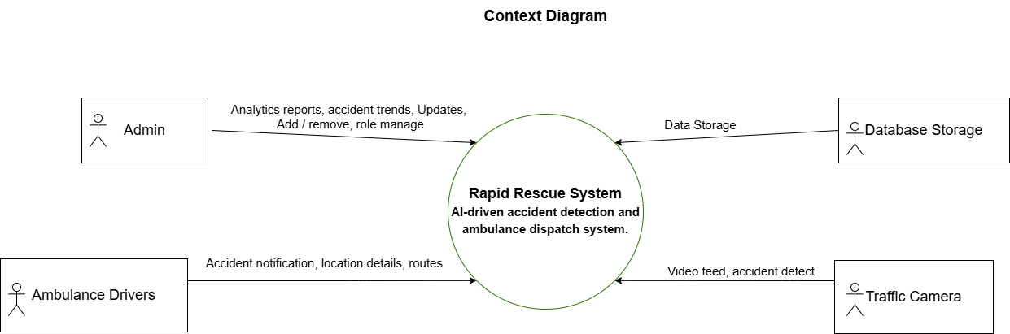

Rapid Rescue system tracks accidents in real-time by processing live traffic camera feeds with computer vision algorithms. After detecting an accident, the system sends instant notifications to ambulances near the scene, sharing exact coordinates and best travel paths through Google Maps APIs. We use the analytics dashboard to show trends and response data for making better decisions and running operations better. Running on cloud technology lets the system grow as needed and handles tasks quickly when connected to other emergency response platforms.

User Classes and Characteristics
1. Ambulance Drivers:
Role: Respond to the incidents and then plot to the location of accidents using the best routes.
Key Features: Notification options that include the location, and route consideration of the presence of traffic.
Characteristics:
- Proficiency in the use of mobile phones, primarily in navigation (GPS system).
- Trained to use the interface and utilize systems features effectively.

2. City Traffic Management Authorities:
Role: Supervise traffic flow, calamity contingencies, and interests that relate to policy.
Key Features:
- Long-term analysis of the incident.
- Generate reports on traffic incidents and emergency response performance.
Characteristics:
- Decision makers worked on traveling distances for route optimization by using collective insights.
- Desires export capabilities for reports and has the need for the custom dashboard.
- Interact with the interface less frequently, primarily for analysis.
3. System Administrators:
Role: Performing maintenance on the software, changing and updating the rights of the users, and including new features.
Key Features: It includes:
- Backend management
- User access and management of permission.
- Encryption for data privacy.
Characteristics:
- Advanced technical knowledge in cloud systems, APIs, and AI frameworks.
- Focused on system maintenance, with less frequent but critical interactions.
Use Case diagram
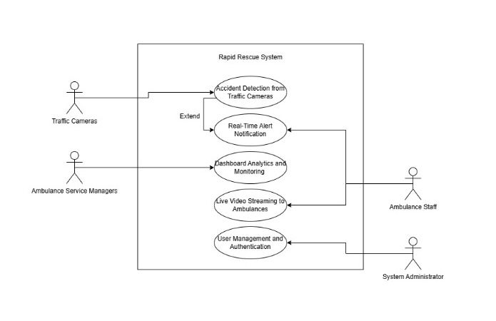

Design and Implementation Constraints
Regulatory Policies
To protect user's privacy and data, the system will have to comply with the existing data protection laws as well as those that are anticipated in Personal Data Protection Bills. Video streams need to be collected and processed in public space and permission may be required. Conditions of use and storage of video feed can be dictated by entities such as NADRA, provincial traffic departments or any other body that lays down the surveillance restrictions. Moreover, actual use of video storage duration must comply with applicable legal regulations.

Hardware Limitations
However, hardware limitations such as low quality of many of Pakistan’s road cameras (especially in rural areas) lacking high-definition capabilities complicate the system. In some areas, camera functionality may be limited if persistent power failures make the cameras suffer from adverse effects. The absence of locally hosted data centers may prevent real-time performance and, as an example, using AWS or Azure as an international cloud service, gives you higher latency. If integrated in large scale services such as Microsoft Azure Pakistan, then that would minimize latency issue. Local development services such as this: TPL Maps (for example) may provide more accurate geolocation data for Pakistani roads than Google Maps API standards might require. Also, AI models need to be developed for recognizing accidents in traffic conditions particular to Pakistan, including traffic flow which is mixed with motorcycle, rickshaw, and bus.

Programming Standards
Modern frameworks and libraries like TensorFlow and PyTorch should be used by the system to avoid creating incompatibility with infrastructure resource constraints. At the same time, considering the speeds of rapid city development, with increased system demands and further video streams to major cities such as Lahore, Karachi, respectively, it must be designed for scalability.

Assumptions and Dependencies
Assumptions
To function properly the system needs clear traffic camera footage plus reliable internet access for urban regions while depending on cloud platforms like AWS for future growth. For the system to work, we must build cooperation with ambulance services and receive trustworthy mapping information from API providers while getting proper regulatory approval.

Dependencies
The project functions with additional mapping and notification features from external providers using cloud-based systems for data storage and real-time functions through HD cameras. Success requires authentic training information plus server access in proximity. Collaborative agreements with emergency workers and official organizations help ensure system performance.

Technical Architecture
Architecture Diagram

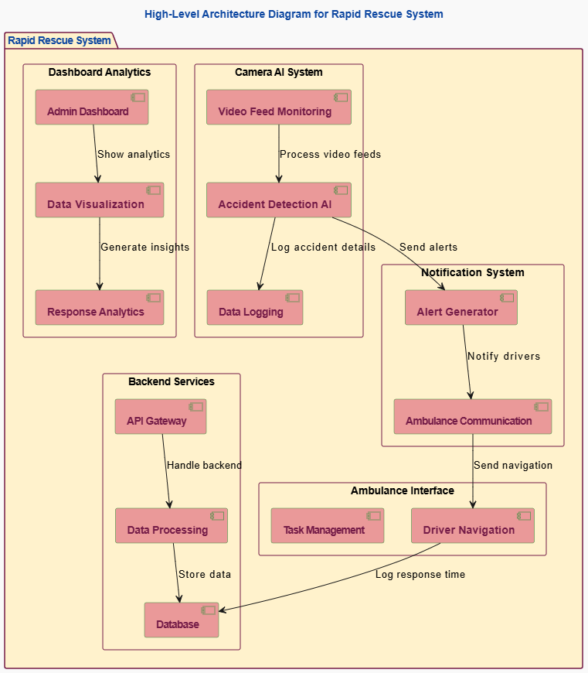

The high-level architecture diagram represents the modular components of Rapid Rescue. It includes video feed monitoring and accident detection AI that detects accidents, a notification system designed for ambiens to alert, and a dashboard that provides analytics. Backend services provide data processing and storage, while the interface for the ambulance will manage task assignments and navigation.

System Type
This custom-built Rapid Rescue system combines artificial intelligence with computer vision to find accidents instantly and direct ambulances.

Processing Type
The system performs real-time accident detection by examining streaming videos in the online mode. It functions by warning emergency services about accidents and showing performance activity in specialized dashboard reports.

Major Application Components
The system's core features contain an accident recognition tool, a live alert platform, monitoring visuals for analysis, cloud computing services, and connections to map providers and messaging systems.

Data Managed by the System
The system processes live video data from accidents, keeps track of ambulance positions, monitors response times, and evaluates accident trends for better emergency services.

Basic Application Architecture
The system organizes functions between a cloud server and client application. Our backend operates from cloud servers and uses a web interface for ambulance staff and admin teams to access information.

Programming Language
Our development approach combines Python for TensorFlow and PyTorch AI model development with JavaScript-powered front-end creation built on React and compatible frameworks.

Hardware Platform
Our system accesses AI model processing through top-tier GPUs located on cloud servers. We use high-definition cameras to stream traffic location videos in real time.

Database Platform
Our database system uses either Redis or PostgreSQL to store accident reports while managing analytics results and user profiles.

End-User Interface
Our web-based interface lets emergency service providers, team leaders, and system operators interact effectively from their web browsers.

Network Architecture
We use cloud hosting services to run our system online while supporting future growth needs. It uses internet protocols to send data instantly from traffic cameras to the cloud server and ambulance services.

System Hosting
We need cloud hosting because it provides flexible growth and stable performance as we expand our system.

Application and Data Architecture

Application Components and Processing Units
The high-level architecture of the Rapid Rescue system highlights its modular components, designed to work collaboratively for real-time accident detection, notification, and emergency response management. Each module specializes for a particular function but seamlessly integrates with others to ensure efficiency and reliability in operations.

Camera AI System
The Camera AI System monitors live video feeds from traffic cameras to detect accidents in real-time. The video feed monitoring unit processes these streams continuously to identify incidents. Once detected, the accident detection module validates the event and logs critical data, including time and location, for further processing. This data is then forwarded to the notification system, ensuring immediate action is taken. The system ensures accuracy in detection, reducing errors and unnecessary alerts.

Notification System
The notification system handles communication between the detection system and ambulances. It produces rich notifications, indicating the location and intensity of the accident. These notifications are forwarded to the ambulance communication module, which notifies the nearest available ambulances. The notification system ensures timely and effective communication, thereby minimizing delays in response. This module plays a critical role in transmitting critical information to the field, thereby ensuring quick assistance.

Dashboard Analytics
The dashboard analytics module provides administrators with tools to monitor and manage the system's performance. It includes a visualization unit that transforms raw data into graphs and charts for easier interpretation. The analytics engine processes incident data to generate reports on response times and patterns. Administrators use these insights to identify bottlenecks and improve operations. This module enables better decision-making through clear and actionable data.

Backend Services
The backend services module manages data processing and storage. The API gateway facilitates communication between all system components, ensuring smooth data exchange. The data processing unit organizes and refines incoming data, which is stored in the database. The database acts as the system's central repository, holding accident logs, notification histories, and response records. These backend services are critical for ensuring system scalability and reliability.

Ambulance Interface
The ambulance interface supports drivers in responding to incidents efficiently. The task management module assigns tasks to drivers based on their proximity to the accident. The navigation module provides optimized routes to accident locations, helping reduce response times. This interface ensures that ambulance staff receive clear and actionable instructions, allowing them to focus on reaching the spot of accident quickly and providing timely assistance.

Logical and Physical Model
The system combines logical workflows and physical infrastructure to achieve seamless operations. Logically, it organizes processes into independent yet interconnected modules, such as detection, notification, and analytics. Physically, it uses cloud-based infrastructure for hosting and data management, with APIs enabling integration across components. This design ensures the system is scalable, reliable, and capable of meeting real-time operational needs.

Component Diagram

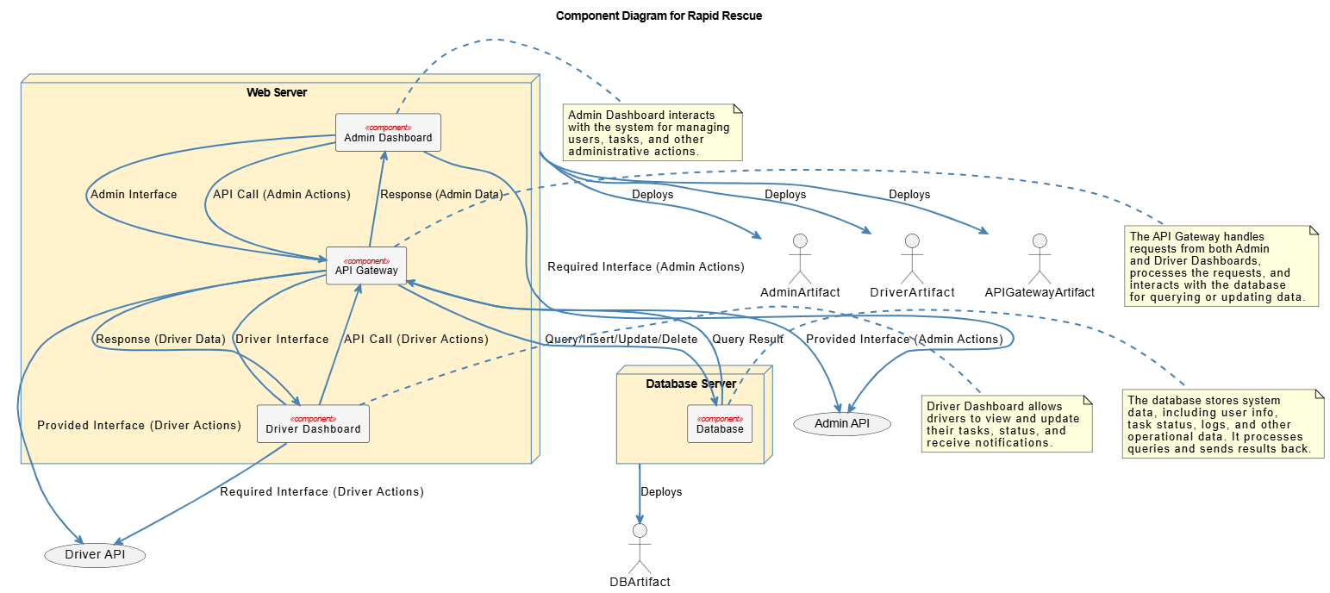

The component diagram represents interactions between the admin and driver dashboards, the API Gateway, and the database. The API Gateway handles requests, allowing data to flow from the dashboards to the database for storage and retrieval of system data in operations.

Class diagram
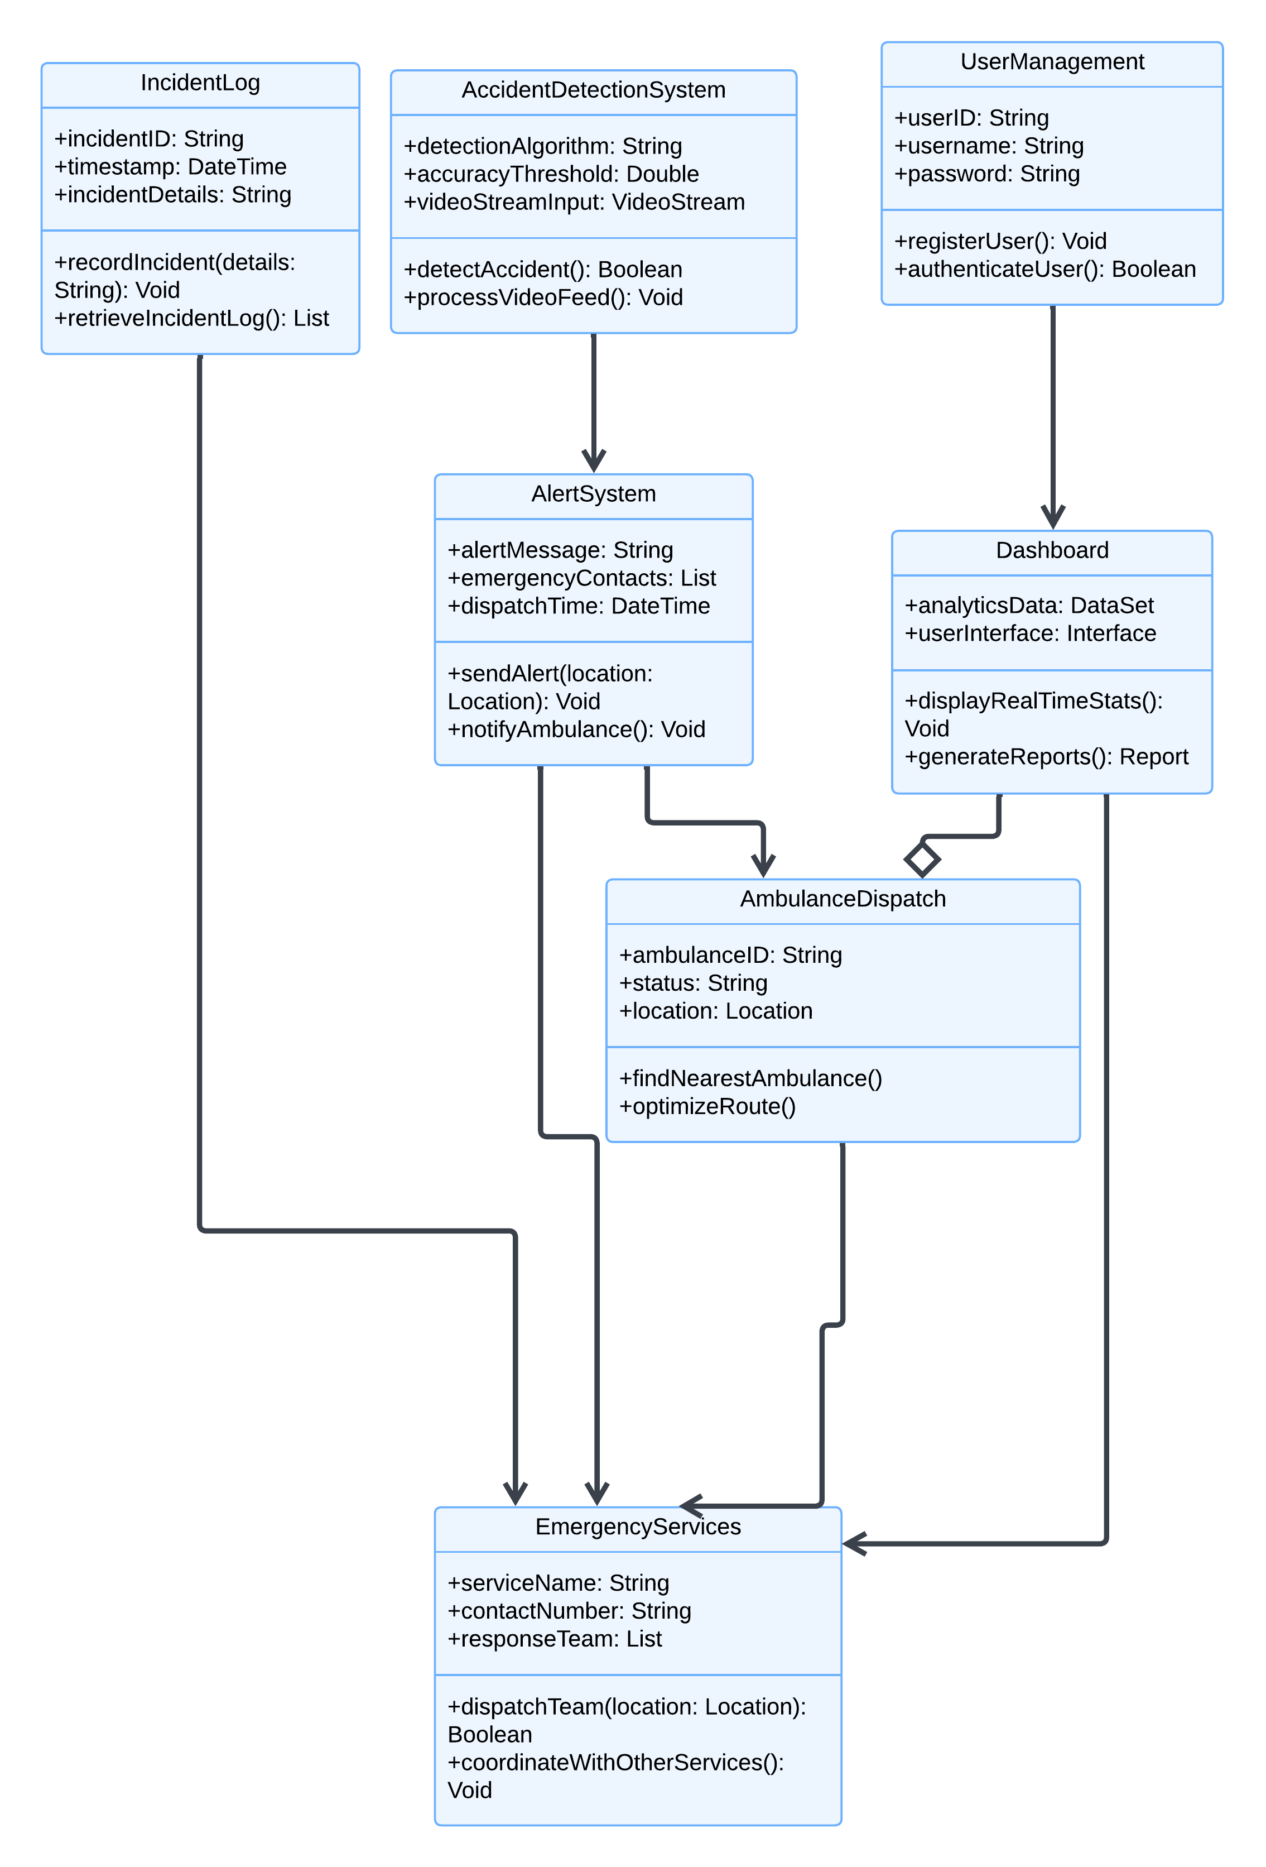

Rapid Rescue identifies accidents to alert emergency teams, prioritizes emergency response routes based on user requirements and keeps track of all processes to monitor safety operations.

Entity Relationship Diagram

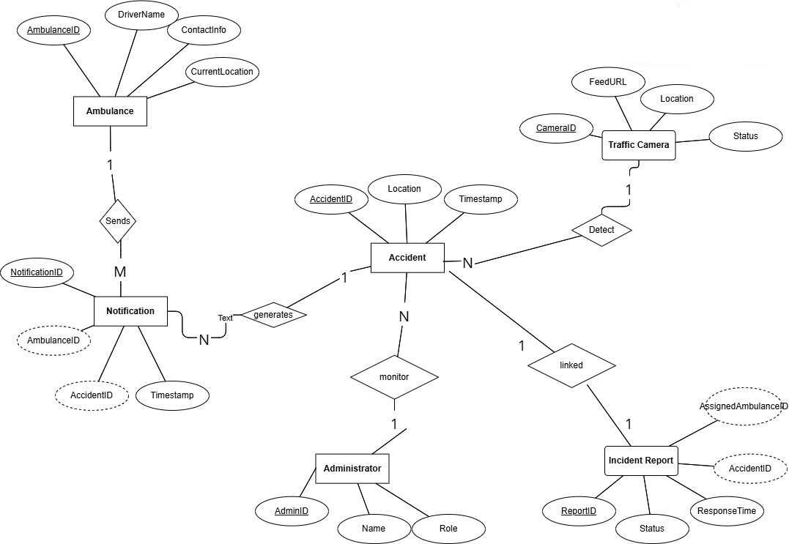

The ER diagram demonstrates how Rapid Rescue combines traffic camera accident detection with ambulance notification systems and incident reports under administrative management.

Decision Tables

Decision Table for Login and Access:
EVENTS | 1 | 2 | 3 | 4
Valid Username | 1 | 1 | 0 | 1
Valid Password | 1 | 1 | 0 | 0
Role Verified (Admin/Dispatcher) | 1 | 0 | 1 | 1
Forgot Password Selected | 0 | 0 | 1 | 0
OUTCOME
Access granted based on role (Admin/Dispatcher) | 1
Access denied |  | 1 |  | 1
Password reset process initiated |  |  | 1

Decision Table for User Actions and Roles:
EVENTS | 1 | 2
Valid Username | 1 | 1
Valid Password | 1 | 1
Role (Admin) | 1 | 0
Role (Dispatcher) | 0 | 1
OUTCOME
Manage users, access analytics, Admin panel accessible | 1
Handle ambulances, monitor accidents, Dashboard accessible with alerts |  | 1

Decision Table for Accident Detection and Response:
EVENTS | 1 | 2 | 3 | 4
Video Feed Functioning | 1 | 1 | 0 | 1
Accident Detected | 1 | 0 | 0 | 1
Ambulance Available Nearby | 1 | 0 | 0 | 0
OUTCOME
Notify ambulance, share location & video feed | 1
Continue monitoring |  | 1
System error alert |  |  | 1
Notify control center |  |  |  | 1

Decision Table for Dashboard Analytics:
EVENTS | 1 | 2 | 3
Accident Detected | 1 | 1 | 1
Response time Available | 1 | 1 | 0
Pick-up time Available | 1 | 1 | 0
Route Awareness | 1 | 1 | 1
OUTCOME
Display statistics generate high-risk zones | 1
Log error, notify admin |  |  | 1
Highlight delays in dashboard, recommend route optimization |  | 1

Decisions Table for System Manager:
EVENTS | 1 | 2
Model Accuracy | 0 | 1
Data Quality | 1 | 0
OUTCOME
Focus on optimizing AI algorithms | 1
Prioritize improving data collection |  | 1

Activity Diagram
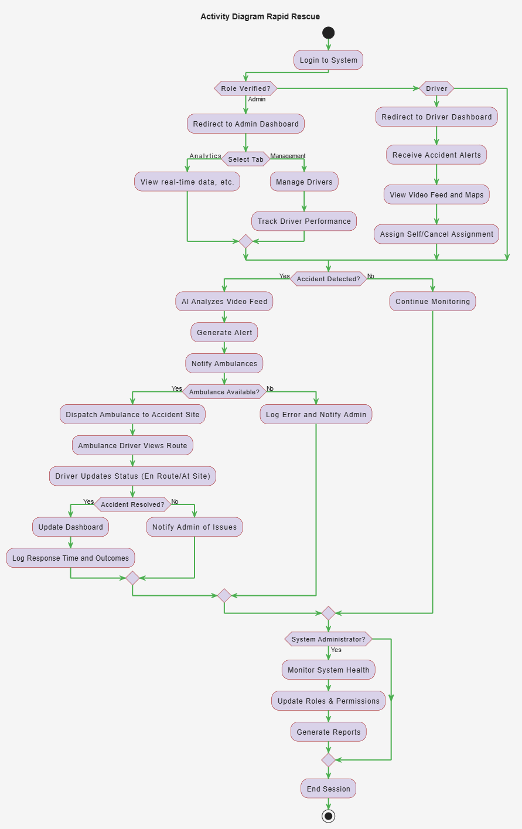
The activity diagram outlines the Rapid Rescue workflow, starting with user login and role verification. Admins manage dashboards and analytics, drivers respond to alerts and navigate accident sites, and the system analyzes video feeds to generate alerts. Monitoring, reporting, and issue management ensure efficient operations.

Component Interactions and Collaborations
The Rapid Rescue system's pieces unite to detect site accidents instantly and launch response teams. The detection system analyses video footage to send alerts to alert emergency vehicles. The dashboard shows monitoring data through analysis as user management controls access rights and roles.
The essential diagrams we use to depict system functions show how data travels among components through methods like sequence diagram and collaboration diagram while also displaying data flows and workflow sequences using activity and DFD diagrams. The network allows emergency teams to detect problems swiftly while sending alerts and tracking system performance.
Sequence Diagram
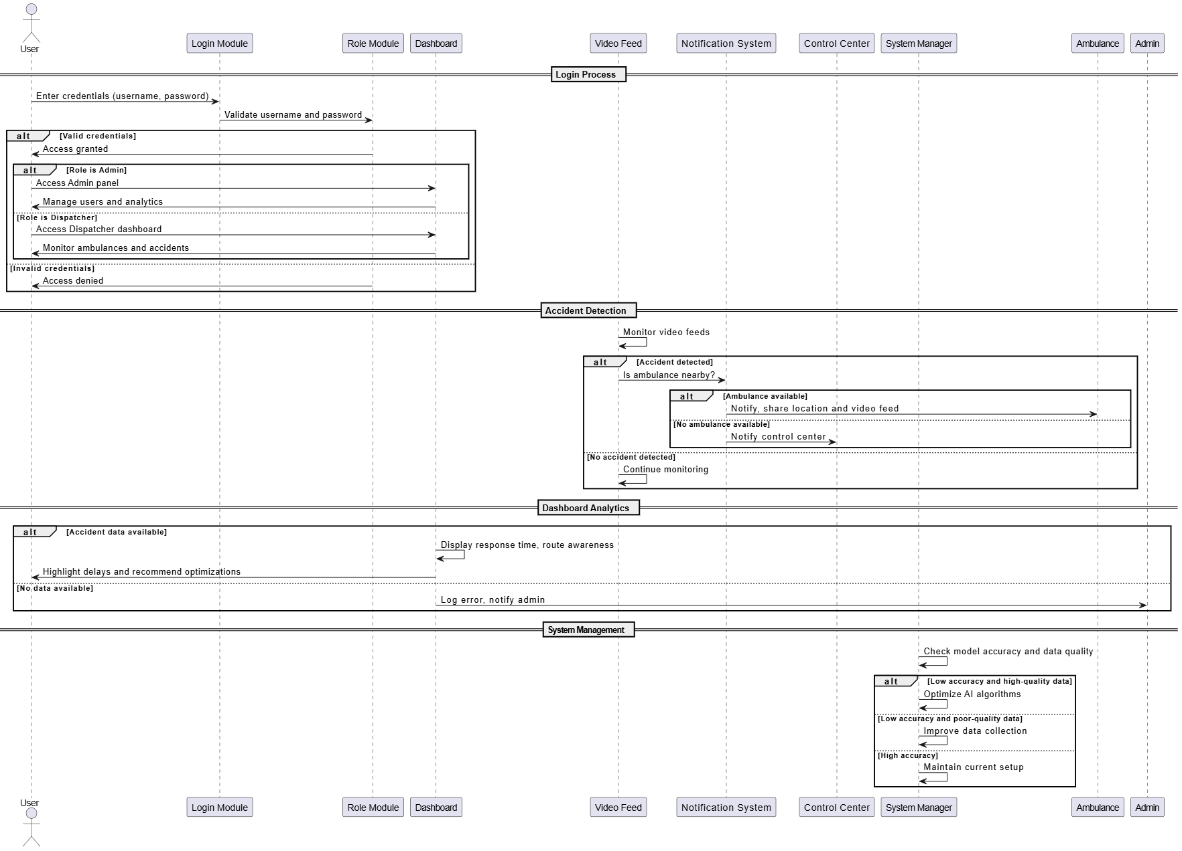
The sequence diagram illustrates user authorization, scene surveillance detection, and emergency service alerts indicating an event. Both the dashboard shows response data while system managers maintain accuracy through system settings. It makes sure events can be found right away and leads to fast notifications for medical teams.

Data Flow Diagram:
Level 0
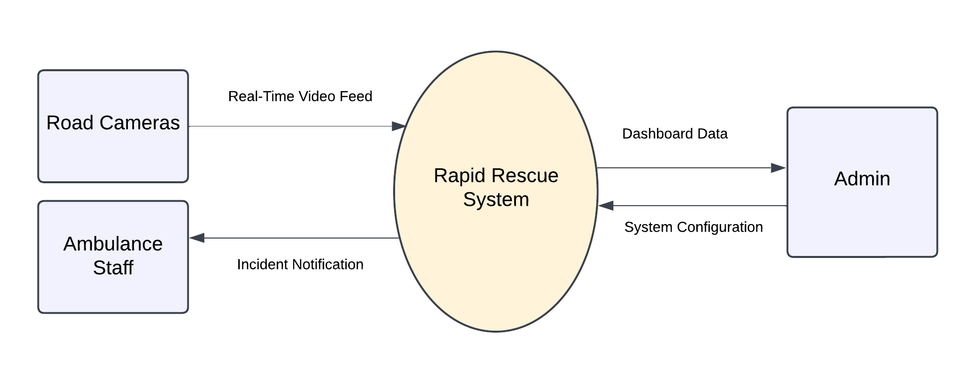
The Level 0 DFD shows the basic functions of Rapid Rescue system. Road Cameras capture live video streams that our system analyzes for events before alerting emergency medical crews. Admins control system options through dashboard monitoring and inspection of analytical data.

Level 1:
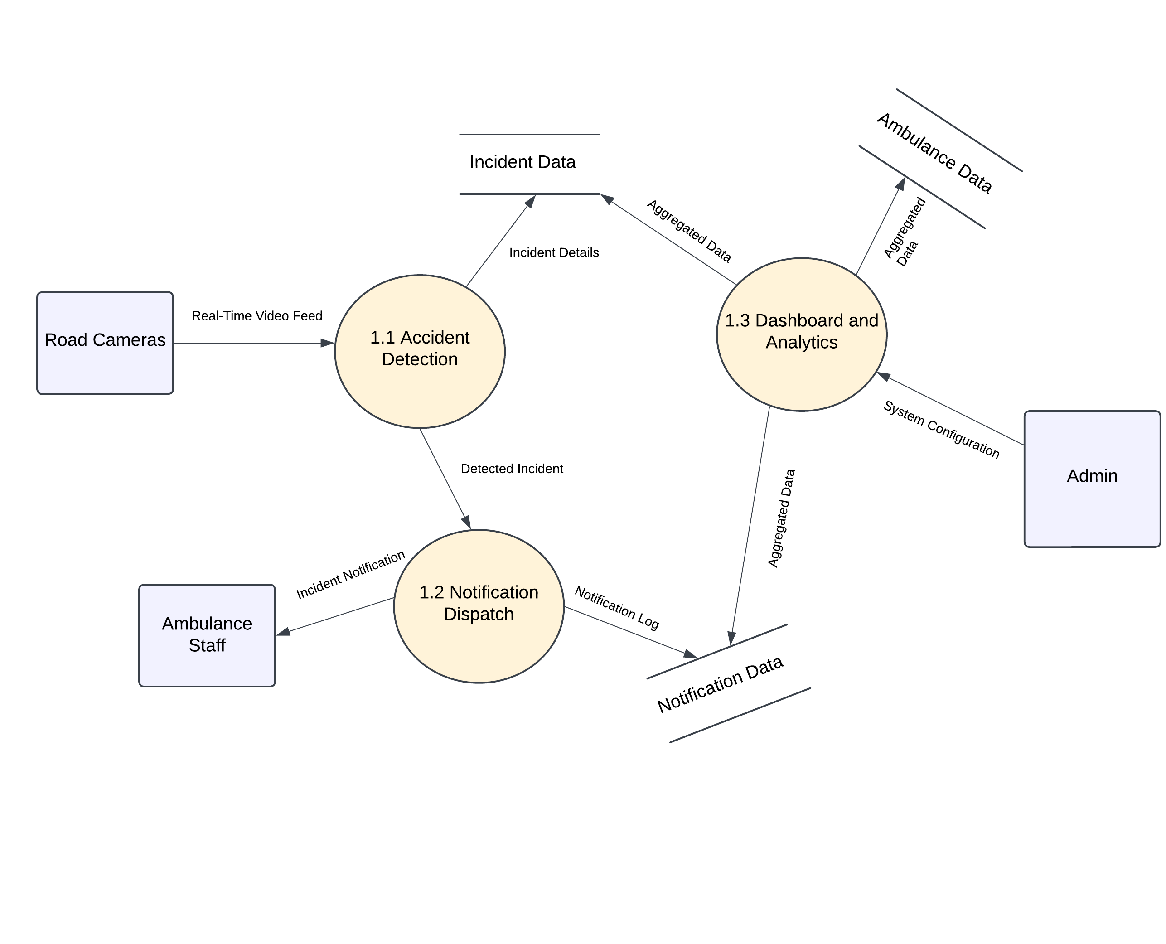
At level 1 we see the system begins by detecting accidents using camera systems which sends notifications to ambulances while presenting data analytics on a dashboard screen. Management teams adjust system settings as data transmission enables quick emergency response actions.
Event Trace Diagram
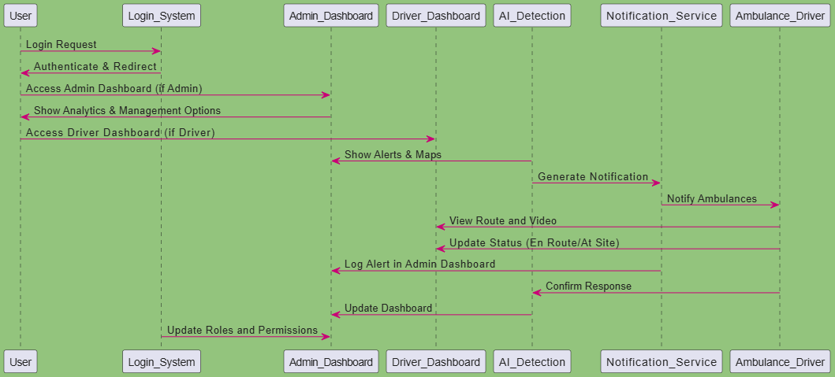
The event trace diagram illustrates the Rapid Rescue system. It first follows the user's login process to the admin or driver dashboard after the redirect process. The AI detection module determines incidents, and in turn, a notification is issued to the ambulance through the notification service. The drivers update their status, while the admin dashboard logs and monitors the response.

Design Reuse and Design Patterns
The development of the Rapid Rescue system incorporates reusable components and design patterns to enhance efficiency and maintainability. Reuse is achieved through modular components such as the accident detection module, notification dispatch module, and dashboard analytics, which can be extended or adapted for similar functionalities within the system.
Design patterns include the separation of data processing and user interface for better scalability. The notification system ensures reusability in alerting ambulance drivers, while the dashboard analytics module can be reused for generating detailed reports and monitoring other emergency scenarios. These patterns streamline development and ensure consistency across the system.

Technology Architecture
Rapid Rescue needs a flexible and strong technical setup to handle its live system processing and information movement. We will build our platform on cloud infrastructure to provide maximal uptime and expanded growth capabilities. The backend uses microservices to support flexible development and simple maintenance of the application.

We chose AWS or Google Cloud as our trusted hosting platform to support video processing and execute alert dispatch and dashboard reporting. We will use RESTful APIs and WebSocket protocols to maintain immediate connection between system parts for fast data transfers.

The system will operate in three primary modes: We gather camera inputs to spot traffic accidents then notify users instantly and track the system performance through dashboards. Our system demands a dependable internet connection to transmit real-time video streams and find the best ambulance routes from current locations. The architecture supports handling many users while connecting easily with Google Maps for route planning services.

Screenshots/Prototype

Workflow
Swimlane Diagram

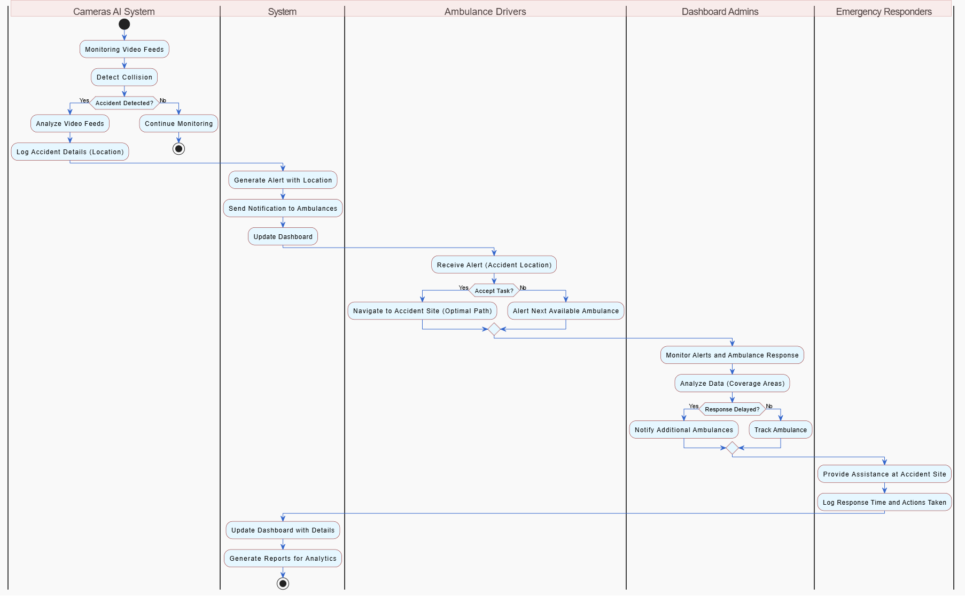

The swimlane diagram shows how the Camera AI System detects accidents, the System generates alerts, Ambulance Drivers respond or reassign tasks, Dashboard Admins monitor responses and log outcomes.

Screens
Admin and Ambulance login/Signup

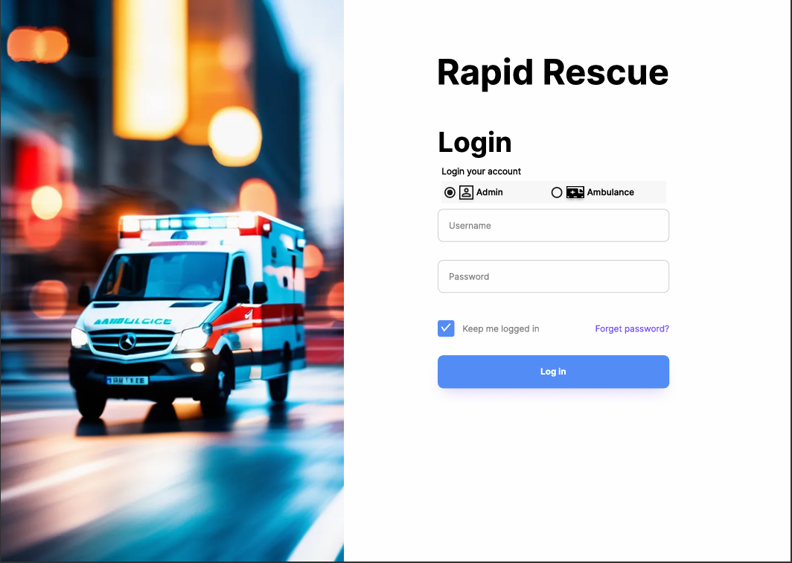

The login screen of the Rapid Rescue system has drop-down options of selecting the user role as Admin or Ambulance along with the facility to input a username and password. Account management has "Keep me logged in" and "Forget password?" check boxes. Background of the image of an ambulance is placed against the login form.

Driver and Ambulance Information (Admin Panel)

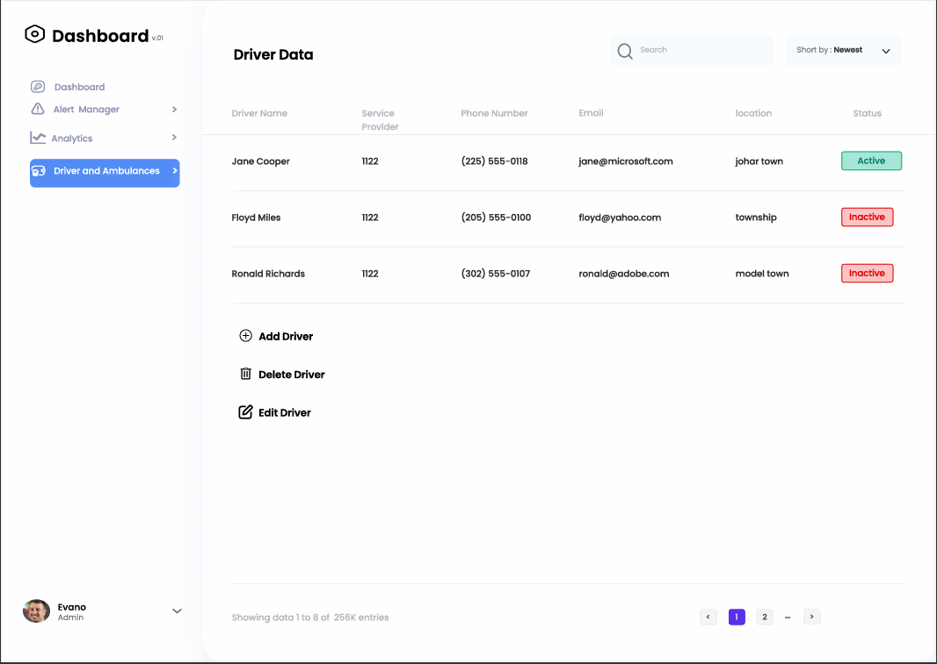

The driver data screen shows driver details organized by name, company they work with, phone contact information, email, current position, and operational status. Users have the choice to create new entries or modify/remove existing driver records from this screen. Users can find and sort driver data through a search tool and sorting function. At the bottom of the page you can move between the different listed entries.

Recent Accidents Analytics (Admin Panel)

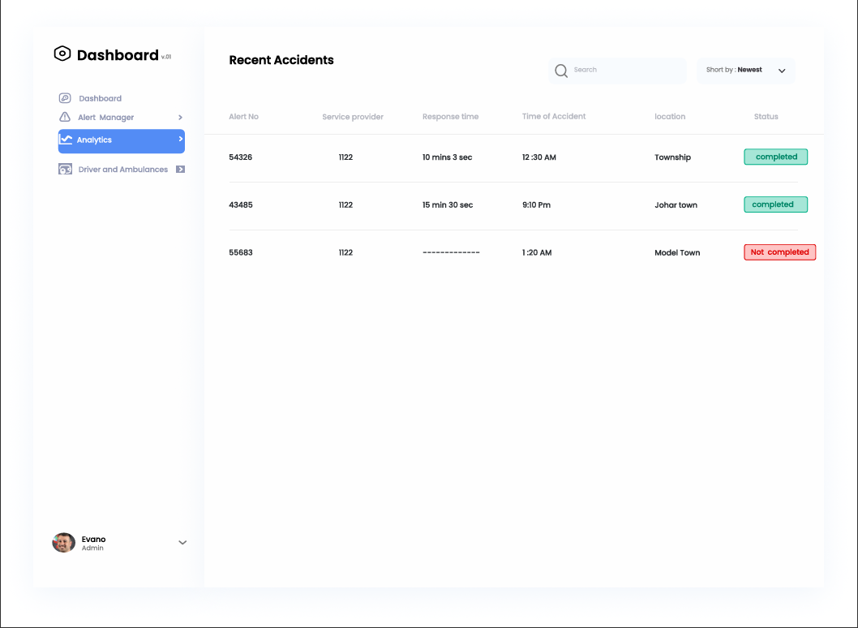

On the recent accidents screen users see a list of alerts about crashes showing alert number, service details, response time, when the accident happened, where it took place, and its status. Users find incidents faster by using the search bar and filter tool with response status labels.

Alert Management (Admin Panel)

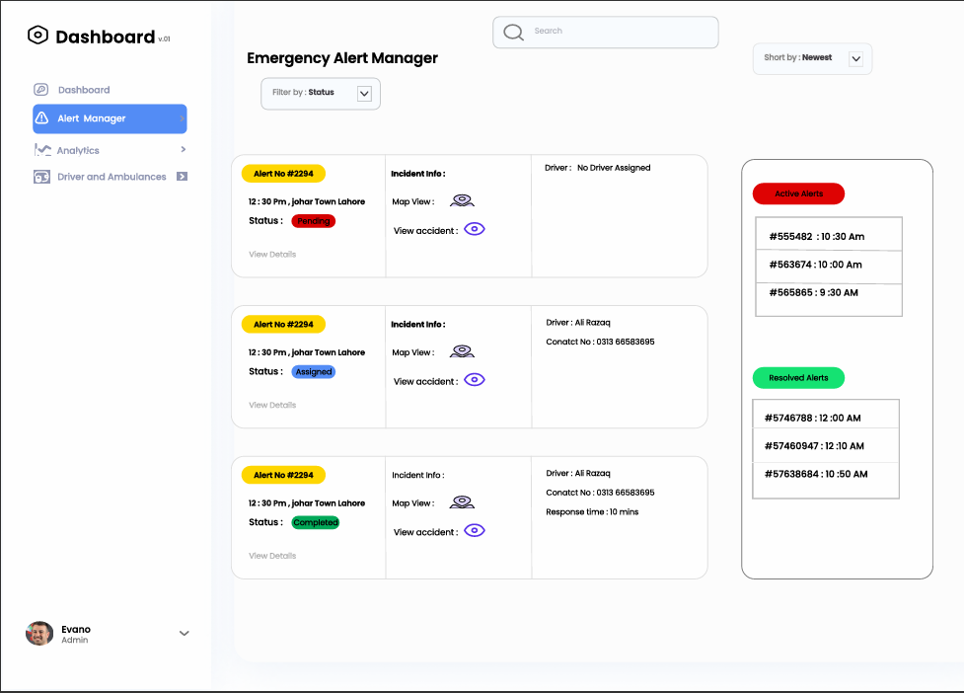

Through the emergency alert manager screen users can view a set of alerts showing numerical ID, timing, geographic coordinates, operational status, and driver records. Users can view incidents on a map screen, filter by status types, and see active and resolved alerts as distinct sections. Our system makes it fast to find and manage your alerts.

Alert Management (Driver Panel)

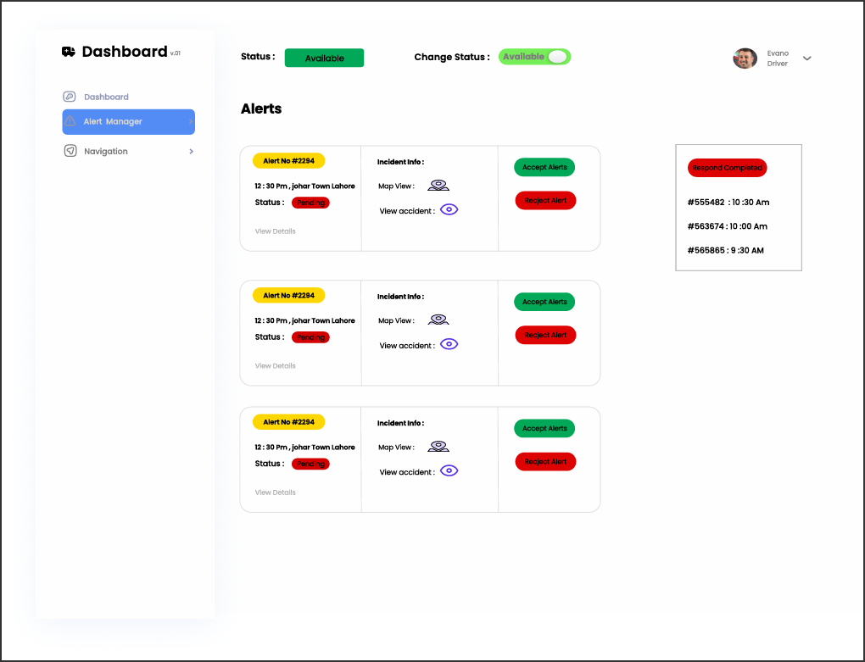

Through the alert management screen drivers can see ongoing alerts with information including alert ID, when they occurred, where they happened, and their current status. Drivers can screen alerts and adjust their availability settings as needed plus access accident map panels. Drivers can use a switch button to modify their response availability while viewing all their previous answers on the display.

Navigation Page (Driver Panel)

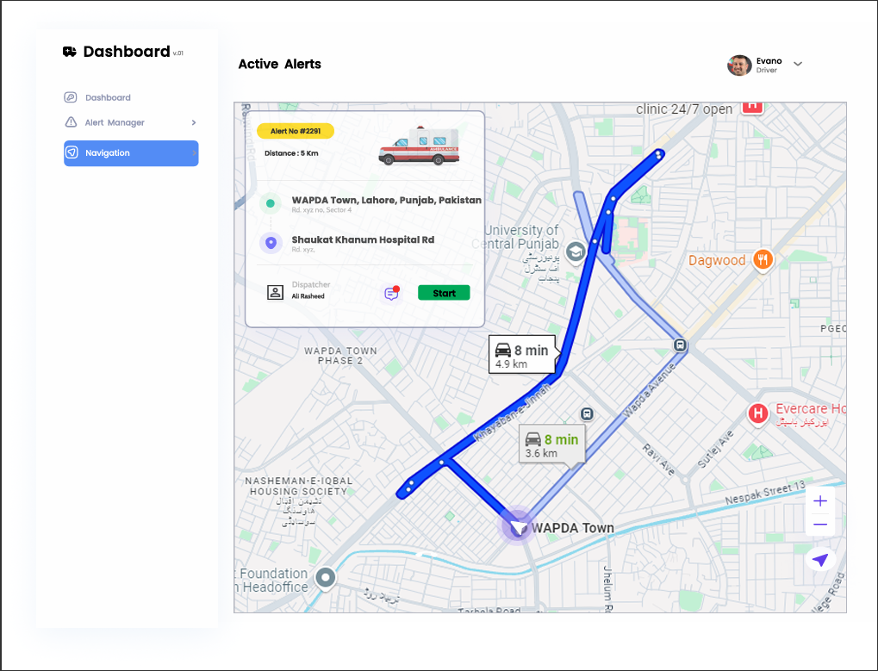

The active alerts screen tells drivers which way to go by showing them the route from their current position to the crash site and final destination. Users can see how far they need to go along with estimated travel time plus the option to activate their navigation. The interface shows main map locations to help users create effective route plans.

Other Design Details
The Rapid Rescue system incorporates supplementary elements designed to expand its usability and prevent performance issues as the technology evolves. Our design takes into account scientific study methods, requires specific hardware and suggests future improvements.

Research-Based Details
The accident detection system uses AI and computer vision to watch traffic in real time. Our system design comes from real-life traffic situations which help it detect accidents under changing weather and lighting conditions. The system chooses efficient detection methods to identify accurate events in our system.

Hardware Dependencies
Our system depends on advanced HD traffic cameras which deliver uninterrupted video footage in real time. Our cloud platform scales efficiently to process live videos and process resulting data effectively. The ambulance interface coordinates through tablet and smartphone devices that contain basic GPS and internet functionality to direct drivers on the road and track mission details.

Future Enhancements
The Rapid Rescue system may expand in the future by adding all emergency departments to create one unified response network. With access to past data we can build predictive analytics to find areas with frequent crashes so emergency response teams can work ahead of incidents. The system could work better with new mapping technology features.

Revised Project Plan
Updated Gantt Chart
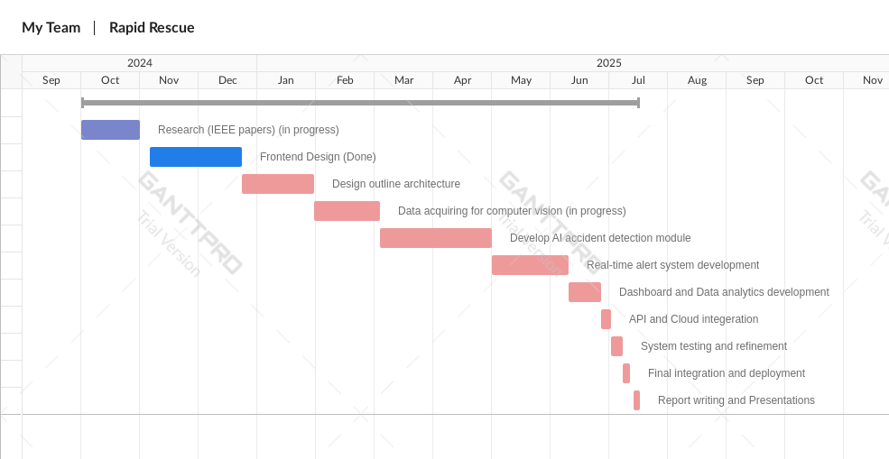

References
- Kamran and Haas (2007) present a multilevel approach using GPS data.
- Škorput et al. (2012) propose a real-time detection system based on road traffic incidents.
- Ksiksi et al. (2015) focused on intelligent traffic alert systems in smart cities.
- Sadaphal (2019) developed an Android-based detection and alert system.

https://app.diagrams.net/
Appendix A: Glossary
A – Glossary
AI (Artificial Intelligence): Thinking and acting like people is programmed into machines programmed to simulate human intelligence.
API (Application Programming Interface): A collection of functions and procedures that permit systems from different computing worlds to interact.
C – Glossary
Cloud Computing: The ability to offer storage and processing power over the internet.
Computer Vision: AI Filed about allowing the machines to understand and choose using visual data.
D – Glossary
Dashboard: A web interface used by ambulance services to monitor real time data and analytics around emergency responses.
Data Analytics: The activity of unravelling datasets to glean useful insights, trends and patterns.
E – Glossary
Emergency Response System: System designed to be coordinated and respond immediately to road accidents.
G – Glossary
GPS (Global Positioning System): Navigation system using satellite to supply location and time information.
P – Glossary
Prediction Accuracy: The capacity to correctly identify or predict specified events like accidents.
R – Glossary
Real-Time Analytics: The real time (or semi real time) analysis of incoming data so business outcomes can be derived while the data is being gathered.
S – Glossary
Scalability: The ability of a system for increased workload or expansions without loss of performance.
Streaming Video: Video data transmitted continuously from a source (traffic cameras) to a receiver (ambulance systems).
T – Glossary
Traffic Cameras: They provide high-definition cameras located all over the road to monitor traffic flow as well as detect accidents.
U – Glossary
Urban Safety: Measures and systems in the place to protect people in the densely populated area, like the city.
User Roles: Enforced access levels and permissions for people touching the system, for example, or ambulance staff or administrators.

Appendix B: IV & V Report
(Independent verification & validation)
IV & V Resource

Name Signature

S# | Defect Description | Origin Stage | Status | Fix Time
 |  |  |  | Hours | Minutes
1
2
3
…
Table 1: List of non-trivial defects

This document has been adapted from the following:
- Previous project templates at UCP
- High-level Technical Design, Centers for Medicare & Medicaid Services. (www.cms.gov)

